# DATABASE MANAGEMENT FOR A UNIVERSITY

1. Create following **STUDENTS** table according to given data type and constraints:

|  |  |  |  |  |  |  |
| --- | --- | --- | --- | --- | --- | --- |
| Column name | S_ID | S_NAME | CGPA | CREDIT_COMPLETED | S_EMAIL | CITY |
| Data type | NUMBER(10) | VARCHAR2(100) | FLOAT | NUMBER(5) | VARCHAR2(200) | VARCHAR2(20) |
| constraint | PRIMARY KEY | - | DEFAULT 0 | DEFAULT 0 | - | FOREIGN KEY |

Answer: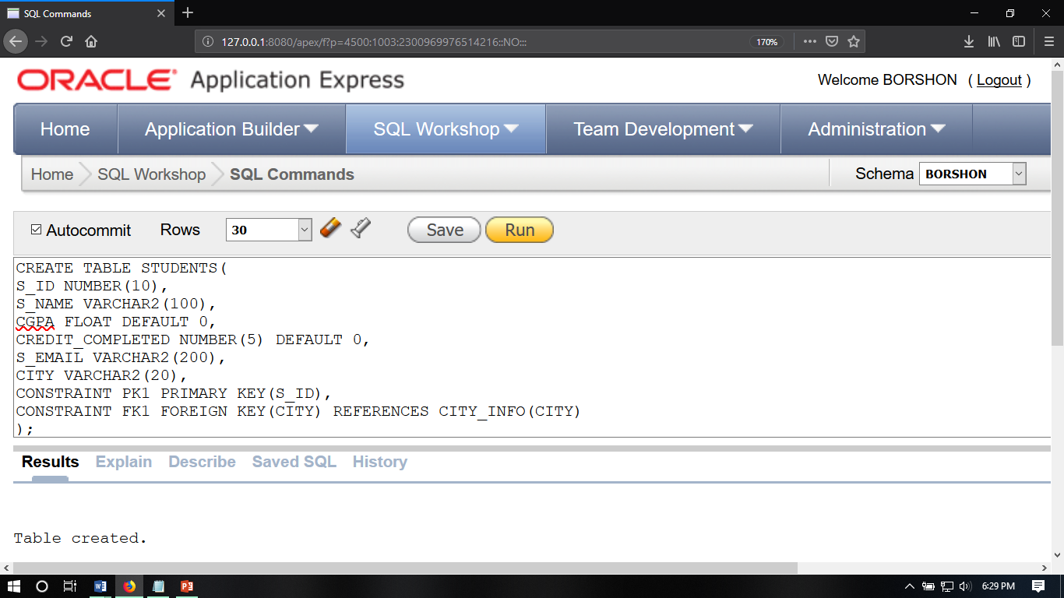

2. Create following **TEACHERS** table according to given data type and constraints:

|  |  |  |  |  |  |  |
| --- | --- | --- | --- | --- | --- | --- |
| Column name | T_ID | T_NAME | JOIN_DATE | PRIMARY_PHO_NO | T_EMAIL | DOB |
| Data type | NUMBER(10) | VARCHAR2(20) | DATE | VARCHAR2(11) | VARCHAR2(200) | DATE |
| constraint | PRIMARY KEY | - | - | NOT NULL | NOT NULL | - |

ANSWER:

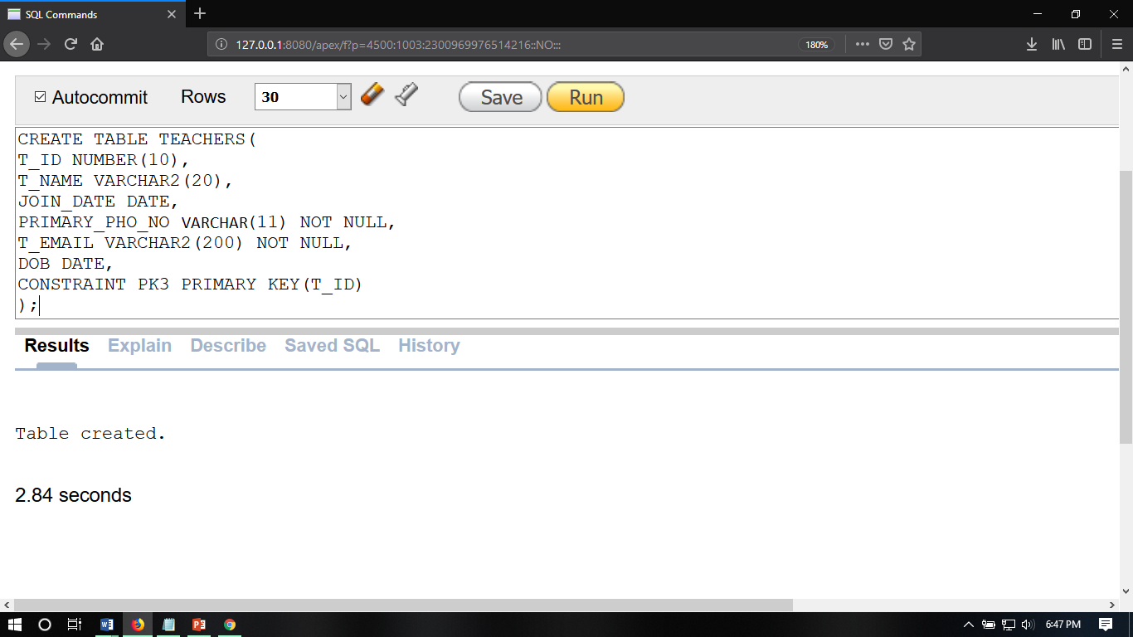

3. Create following **COURSE_DETAILS** table according to given data type and constraints:

|  |  |  |  |
| --- | --- | --- | --- |
| Column name | COURSE_ID | ASSIGNED_ROOM | TIMING |
| Data type | NUMBER(10) | NUMBER(10) | VARCHAR2(10) |
| constraint | PRIMARY KEY | PRIMARY KEY | PRIMARY KEY |

ANSWER: 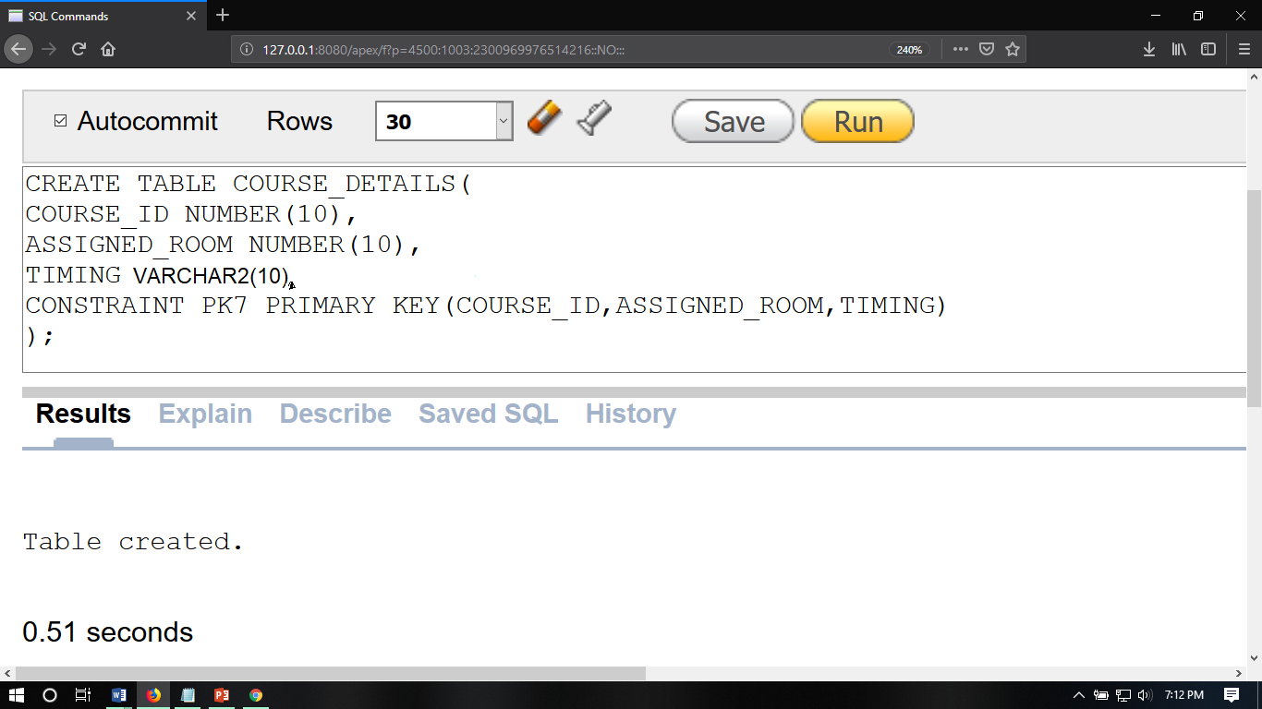

4. Create following **BOOKS** table according to given data type and constraints:

|  |  |  |  |  |  |  |
| --- | --- | --- | --- | --- | --- | --- |
| Column name | BOOK_ID | BOOK_NAME | AUTHOR | CATAGORY | NO_OF_COPIES | AVAILABILITY_OF_BOOKS |
| Data type | NUMBER(10) | VARCHAR2(100) | VARCHAR2(100) | VARCHAR2(100) | NUMBER(10) | VARCHAR2(3) |
| constraint | PRIMARY KEY | - | - | - | - | - |

ANSWER:

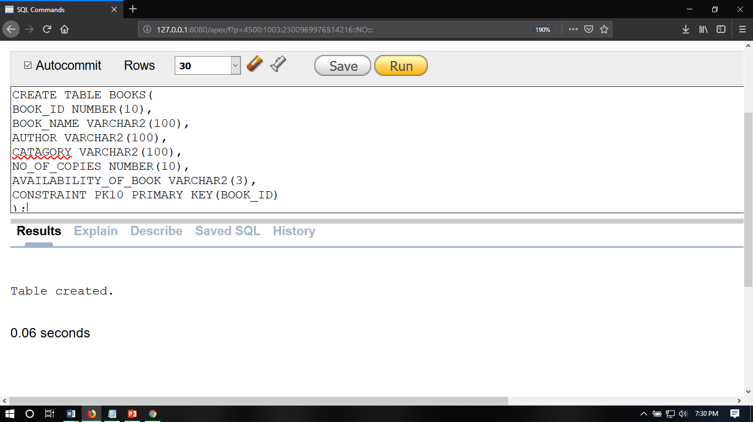

5. Create following **T_VS_S** table according to given data type and constraints:

|  |  |  |
| --- | --- | --- |
| Column name | T_ID | S_ID |
| Data type | NUMBER(10) | NUMBER(10) |
| constraint | **-** | **-** |

ANSWER:

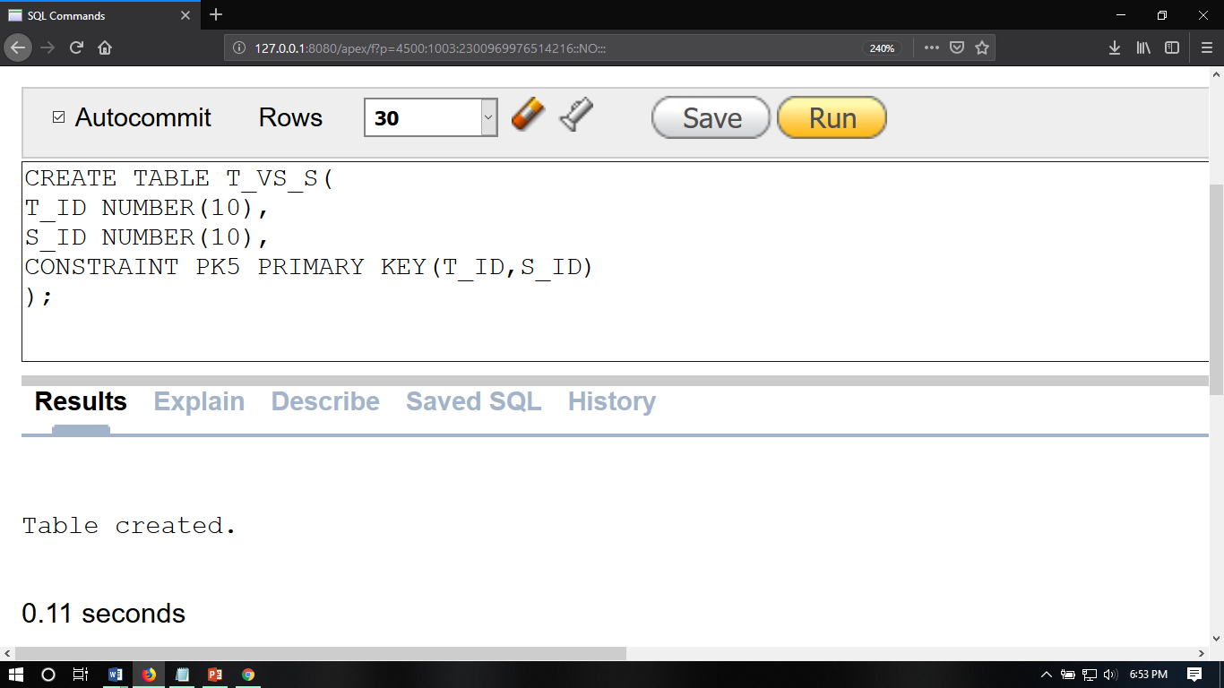

6. Show the data of STUDENTS,TEACHERS,COURSE_DETAILS,BOOKS and T_VS_S tables:

STUDENTS:

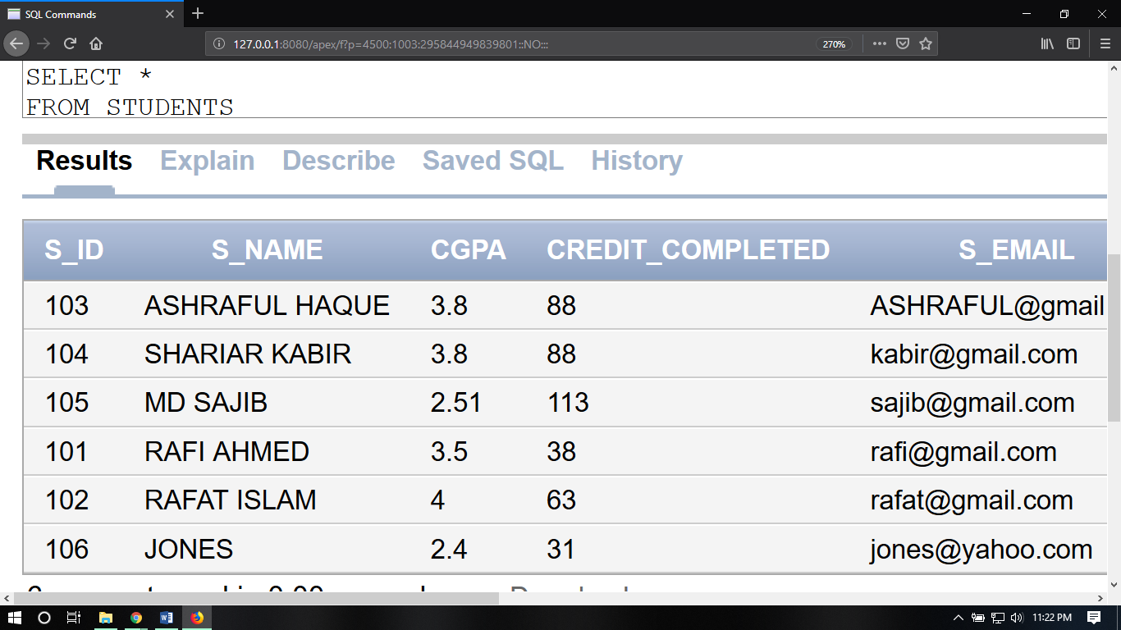

TEACHER:

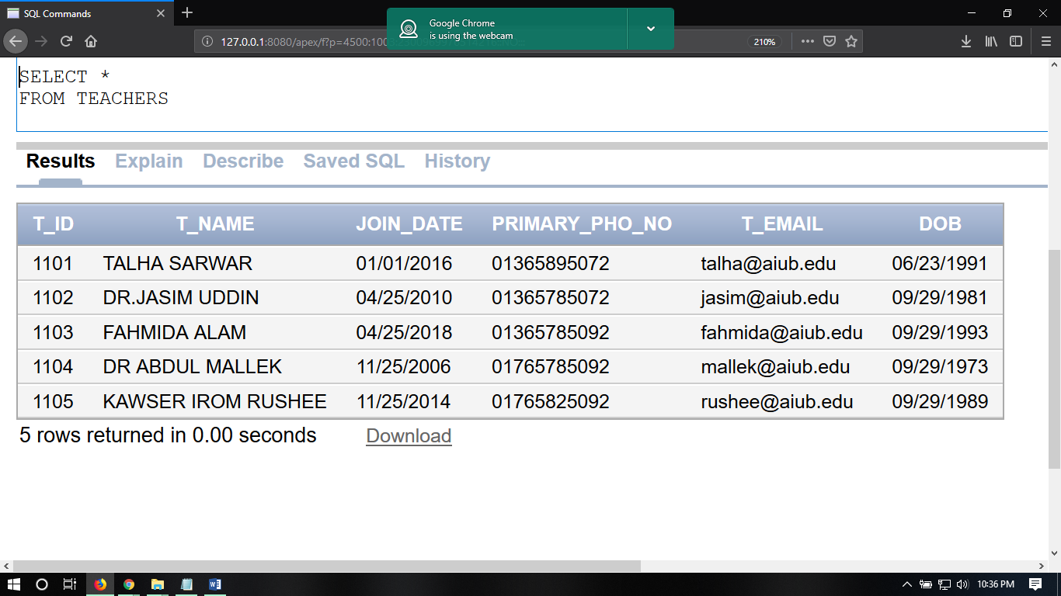

COURSE_DETAILS:

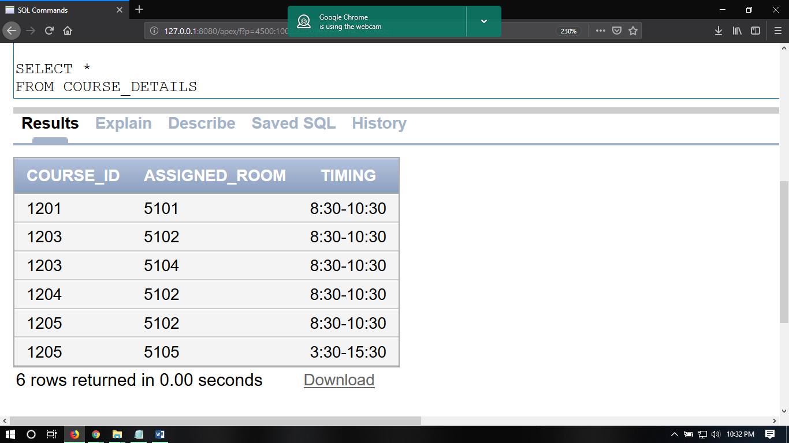

S_VS_T:

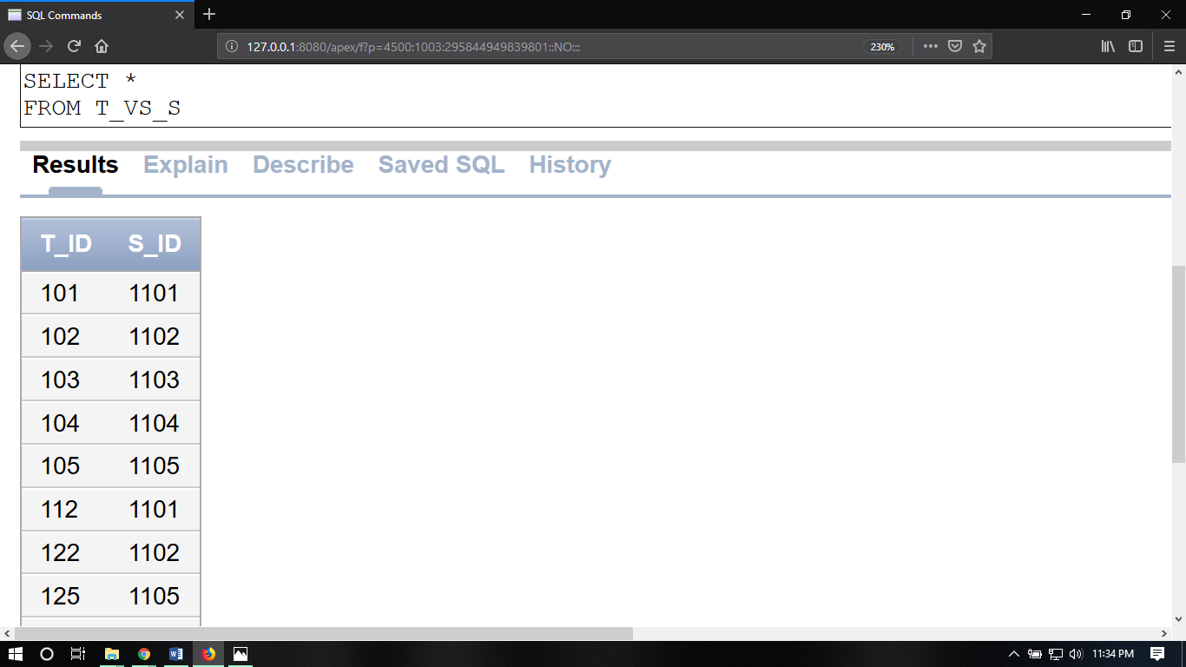

BOOKS:

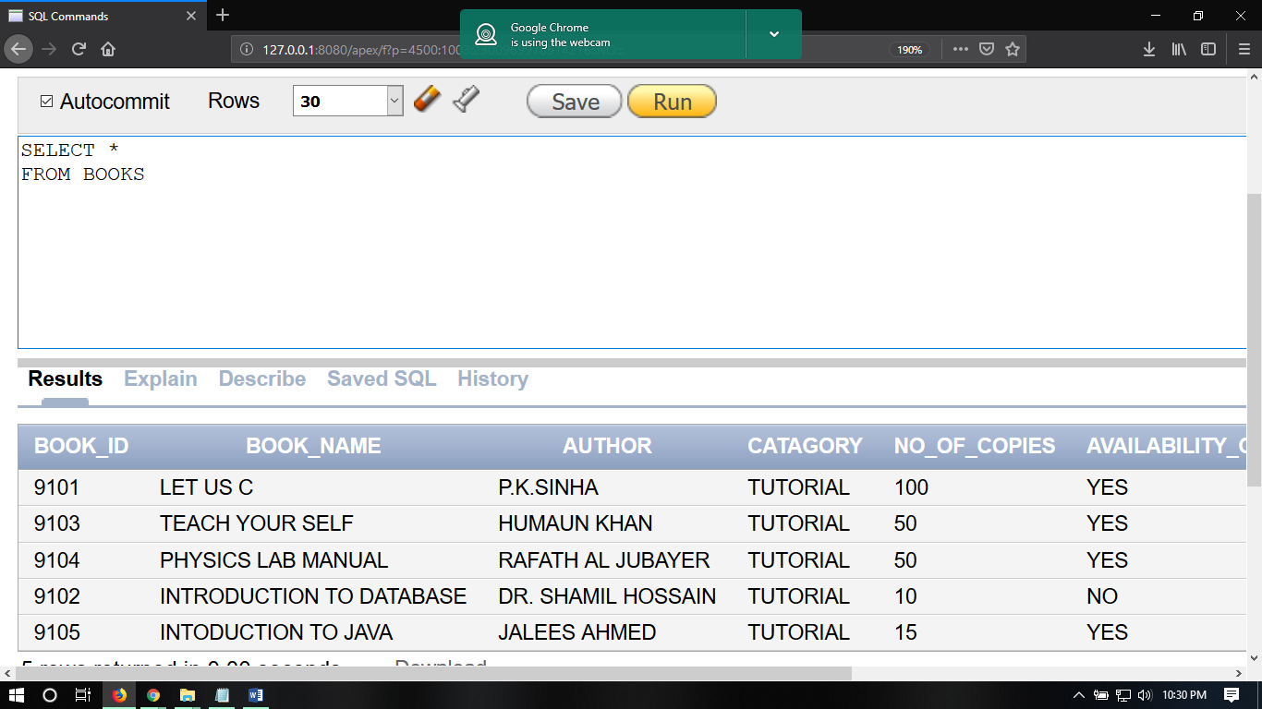

7.Display the students who have class in room number 5101.(use joining)

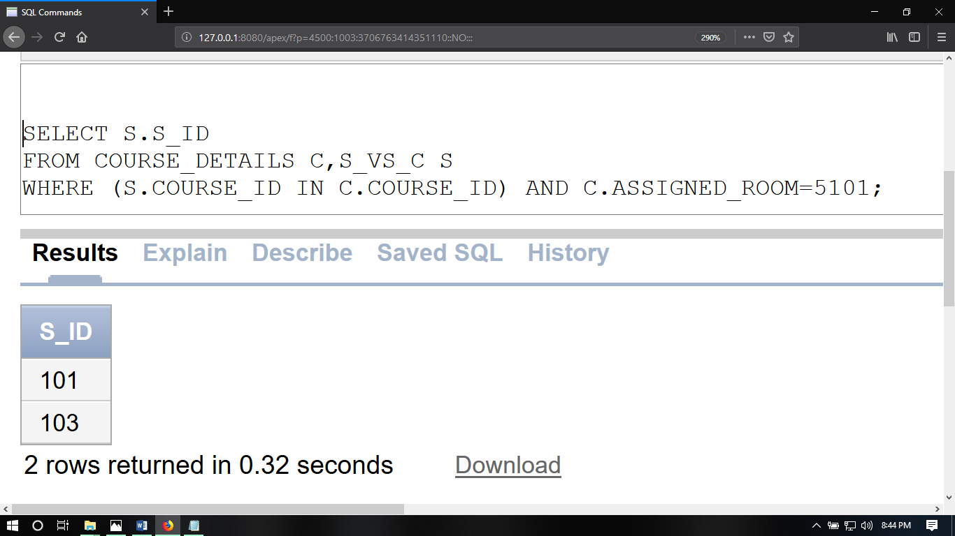

8.Display the students and the teachers who have borrowed the same books.(use joining)

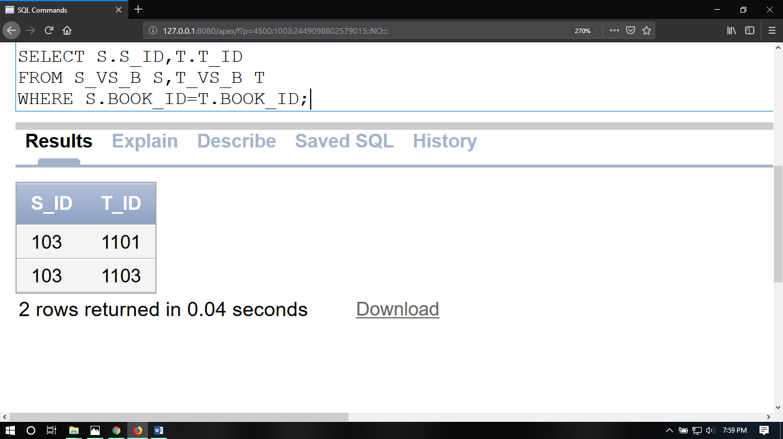

9.Display the students who have failed to return the borrowed books within the due date.(use joining)

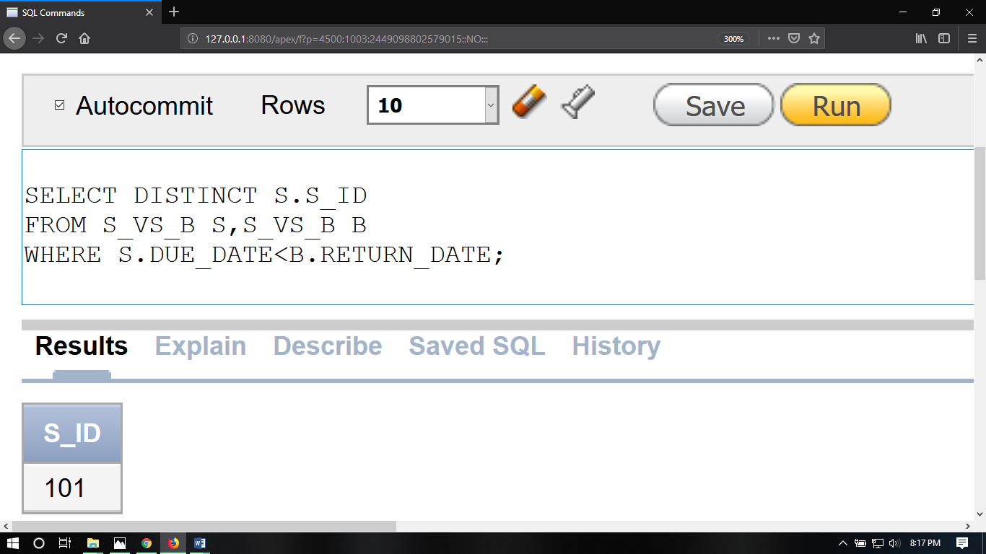

10.Find out the room numbers where class is held between 8:30 to 10:30.(use joining)

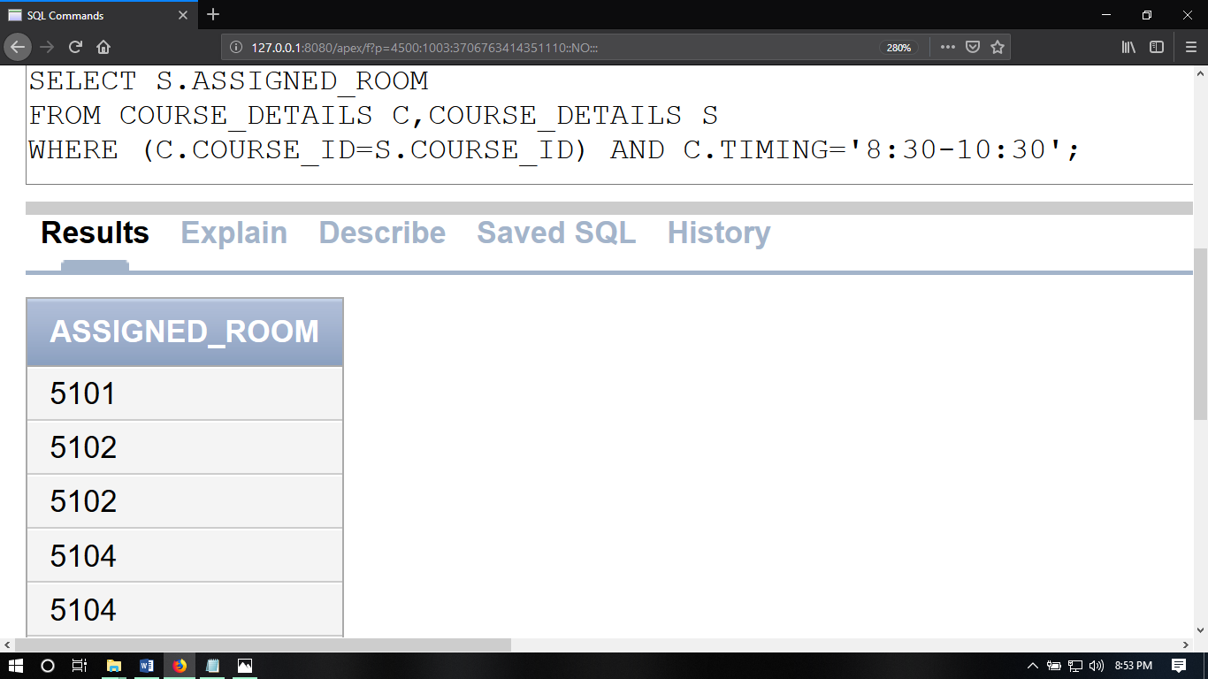

11.Find out the student id, student name who have taken database course in this semester.(using sub query)

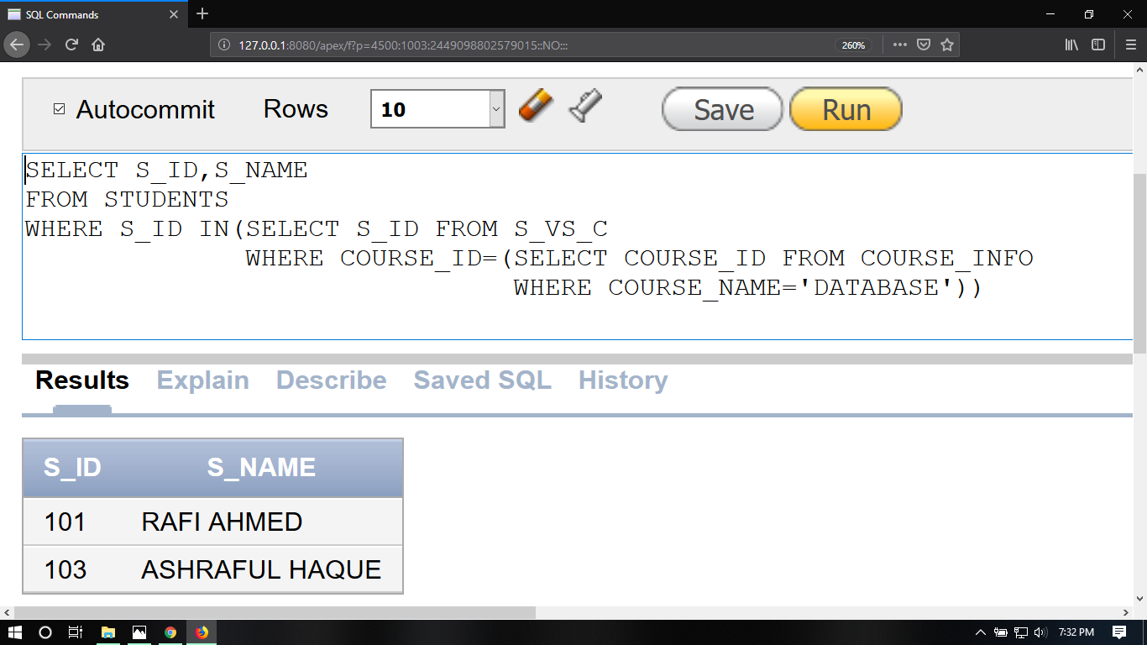

12.Show the availability of the books which are borrowed by MD SAJIB.( using sub query)

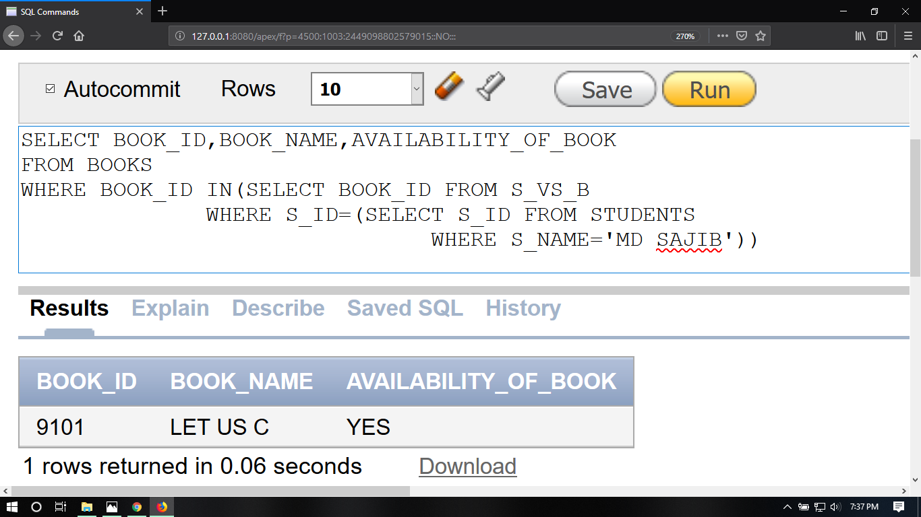

13.Determine the student who is not from BD.( using sub query)

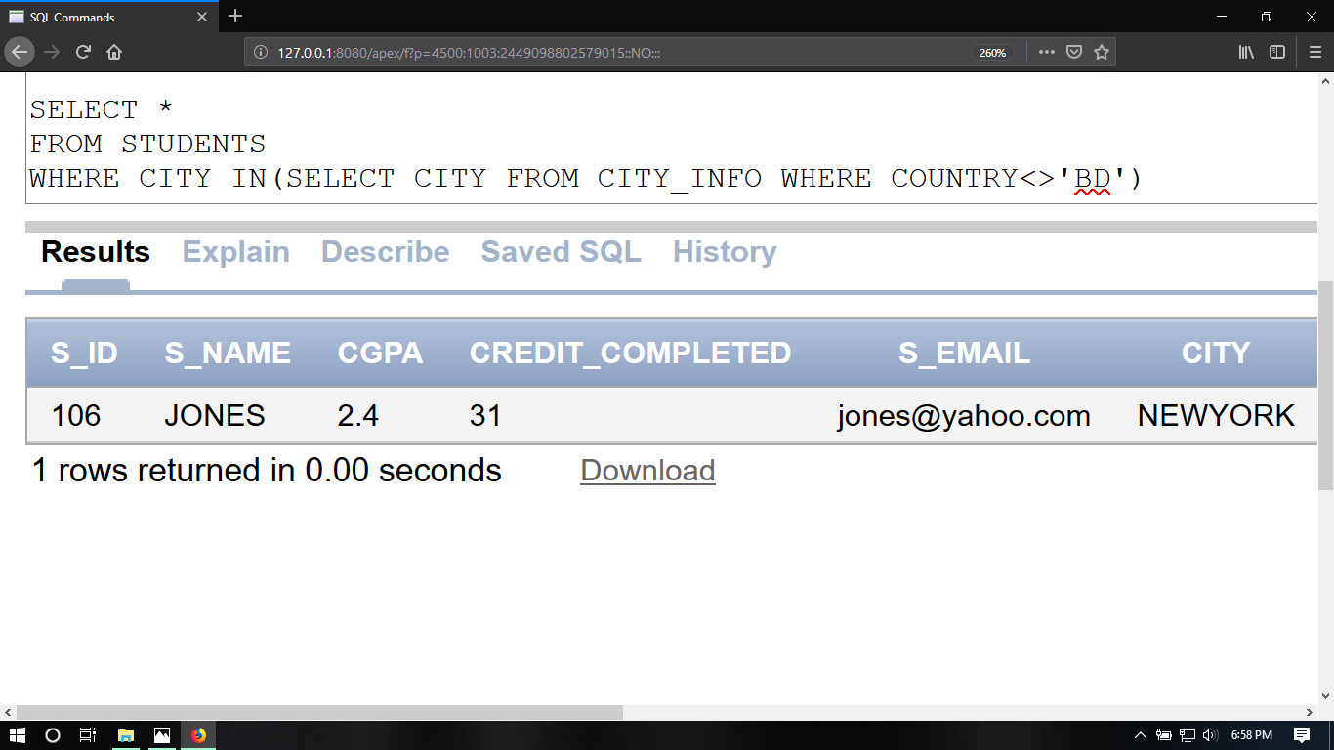

14.Display the student id who got the minimum CGPA.( using sub query)

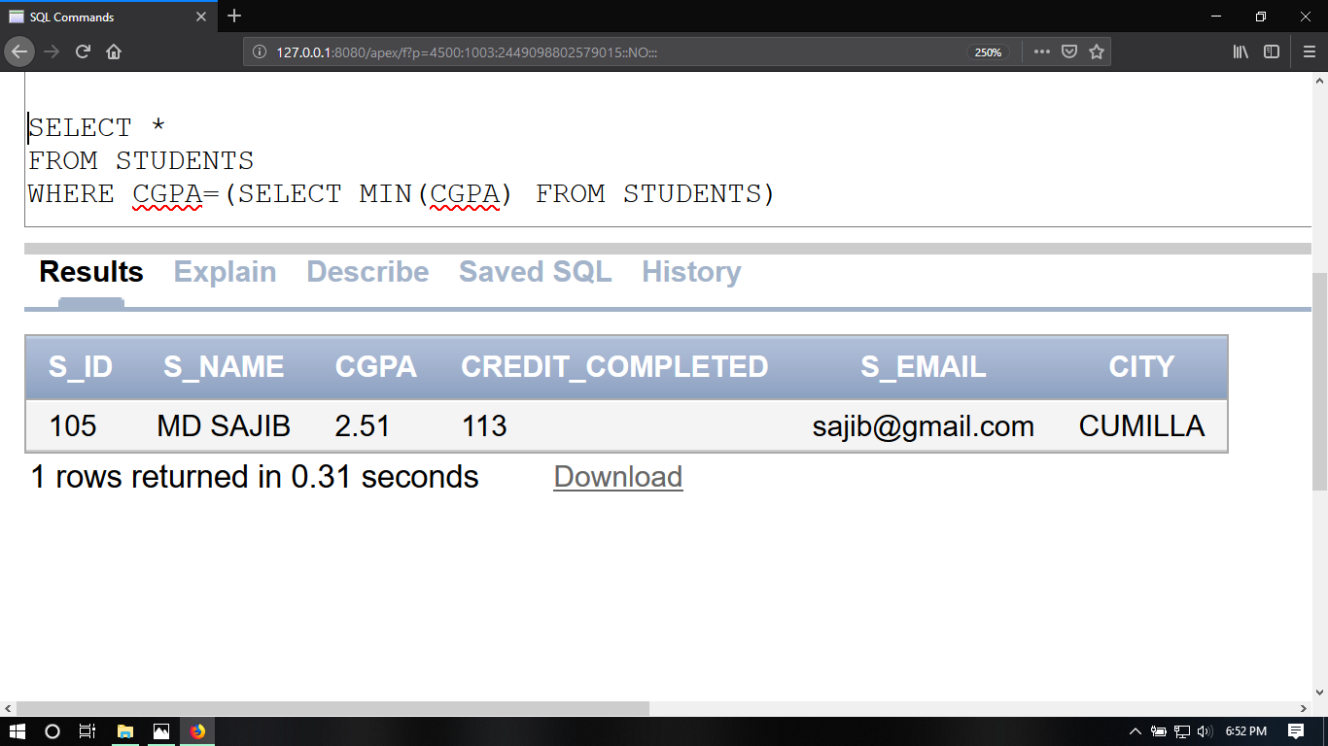

15.Disable the primary key constraint of students table.

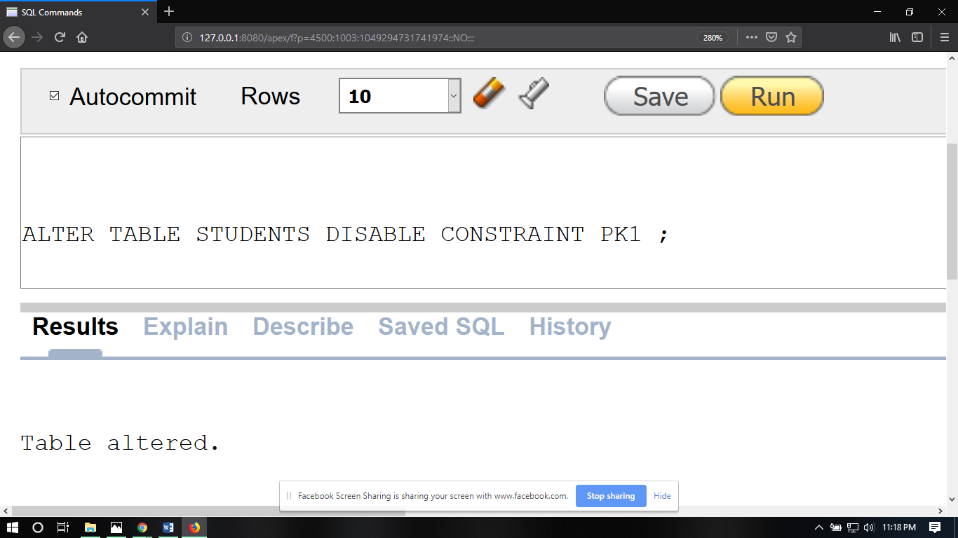

16.Enable the primary key constraint of students table.

